**DP FLOW MEASUREMENT TECHNIQUE**

**2. Flow Measurement Techniques**

**“**Broad description of various flow measurement techniques and their comparison with dp flow measurement to explain the importance of multivariable sensors.**”**

**2.1 Flow Measurement Techniques:**

Measurement of the fluid flow, either a liquid or gas, is commonly a critical parameter in many process industries to cut down their costs. In most operations this can be inked to the basic “recipe” of the process – knowing that the right fluid is at the right place and the right time [1]. However, some applications require the accurate flow measurement in order to make a good product, health and safety, which ultimately can make the difference in making a profit or running at a loss. The accurate flow measurement plays an important role in the process industry due to the following reasons:

1. The maintenance of definite flow rates is important for maximum efficiency and production.
2. Costs which are based on flow measurements will be incorrect if the measurement are erroneous because huge volumes of gas, steam, and liquid may have to be measured daily, a very small percentage error can amount to large sums [2].
3. Let us consider, for example, a fuel station that pumps 10000 gallons of oil per minute and a flow measurement error of just 0.02% will result in the loss of 68 barrels per day. At 41€ per barrel, will result into nearly a 1€ million per year.
4. Accurate calibration of the flow measuring device has to be performed before it is put into operation to cut down the percentage of error.

Generally, a flow rate is the measure of how fast something moves from one place to another place, or distance divided by time. The most important point to be taken in to consideration is ‘There is no direct flow sensor and it is estimated with the help of other process parameters like mass, velocity, differential pressure etc.’ There is a perplexity in flow rates of any fluid because the flow rates are not created equal. In order to understand the flow measurement more precisely there is a need to understand the following terminology:

**Mass flow rate:** It is the amount of a mass moving through a given area of a surface for a given amount of time [3]. It can be expressed with units kilograms / Second, pounds / hour, etc. The mass flow rate does not depend on the change of temperature or pressure. As the mass is influenced by gravity, when the application is dealt with earth, mass flow is not affected since the gravity is constant. The mass flow rate will be relatively constant when a fluid is flowing through a pipe with constant pipe dimensions.

**Volume Flow rate:** It is the volume of a substance through a given area of surface over a given time [3]. Most common units of volume flow rate are m3/Sec, ft3/Sec, etc. The volumetric flow can be derived from the mass flow rate by dividing the mass flow rate with fluid density. If the volume is fixed, the pressure will increase when the temperature is increased and when the pressure is increasing the volume measurement is reduced [4]. Hence, the volumetric flow rate is dependent on temperature and pressure.

Volume Flow rate = $\frac{Mass Flow rate}{Density}$

Currently, there are many flow measurement devices which use different flow technologies in the market from which a user can choose. A brief description of each technique is as follows:

**2.1.1 Coriolis Flow Measurement:**

A coriolis flowmeter works on the principle of “Coriolis Effect”, a coriolis force is an inertial force that acts on objects that are in motion relating to rotating reference frame. These flow meters offer a direct approach to measure the mass flow, Hence can be considered to be true mass meters and provide the accurate measurement. Since, mass does not change, no adjustments are needed for varying fluid characteristics. In general, a coriolis flowmeter contains a vibrating tube in which a fluid flow causes changes in frequency, phase shift or amplitude and the resulting signal is directly proportional to the real mass flow rate.

The measuring principle is based on the controlled generation of Coriolis forces. These forces are present when both translational and rotational movements are superimposed [5].

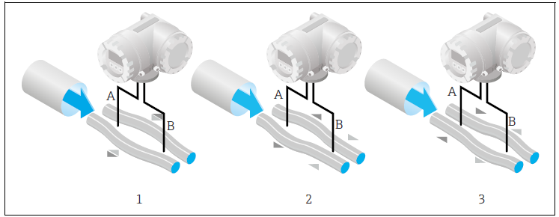

Fig. 2-1: Coriolis Flow Measurement Technique (Source: E+H Coriolis flow)

The Coriolis force developed inside a pipe with flowing with fluid can be represented by,

$$FC =2*∆m\left(V* ω\right)$$

Where, FC = Coriolis force,

Δm = Moving Mass

ω = Rotational Velocity,

V = Velocity of the moving mass in a rotating or oscillating system

When a fluid is flowing through a pipe, the amplitude of the Coriolis force depends on the moving mass Δm, velocity of the fluid and on the mass flow. The angular velocity is dependent on the oscillations of the tube. The Coriolis force developed at the two instances of the measuring tube creates a phase shift. At 0% flow rate, both the tubes oscillate in phase (1) and at other flow rates the mass flow causes deceleration of the oscillation at the inlet of the tubes (2) and acceleration at the outlet (3) as shown in fig. 2-1 [5]. Despite these factors and there are many features encrypted in the coriolis flow measurement technique which are as follows:

* The cross section of the tube is generally less than the tube cross section to improve the coriolis forces.
* The phase difference between the measuring tubes increases with increasing mass flow.
* This flow measurement technique is independent of temperature, pressure, viscosity ad flow profile.
* A change in mass results in change in density of the oscillating system and hence the resonance frequency is the function of fluid density.
* These flow meters are not affected by change in Reynolds number, velocity, density, viscosity.
* A Coriolis meter can be applied for variety of applications ranging from adhesives and coatings to liquid nitrogen.

**2.1.1.1 Advantages of Coriolis meters:**

**2.1.1.2 Disadvantages of Coriolis meters:**

**References:**

1. https://www.petro-online.com/articles/flow-level-pressure/12/ashley_buck/the_importance_of_mass_flowmeasurement_and_therelevance_of_coriolis_technology/1729/
2. <http://www.auduboncompanies.com/the-importance-of-flow-meter-accuracy-in-gathering-operations/>
3. <http://www.tangentlabs.com/clientuploads/Newsletter/February%202011/Volumteric%20vs%20Mass.pdf>
4. <https://sagemetering.com/back-to-basics/comparing-mass-flow-rate-to-volumetric-flow-rate/>
5. <https://portal.endress.com/wa001/dla/5000275/1921/000/02/TI00101DEN_1314.pdf>